**ORM / Web Services Final Project**

# **Topic: Article Post**

## **Instructor: LYPENGLEANG SEANG**

### **Group 6 members:**

* CHEA CHAN
* CHEA DEVIT
* NEAM SINAT
* DANET THORNG
* CHANTHA ROEURN
* CHHUNHAK CHHOEURNG

**University of Puthisastra**

1. **Introduction**

**Article Post** is very important for people's life currently, because it gains knowledge of everything like working, news, general knowledge, and technology.

Article post: is a website that can help the human to daily activities. This website helps people to find information easily.

**1.1 What is the project?**

The project is the Article Post, it provides the news and articles within Entertainment, Sports, Technologies, Ideas, Photo, Video and Socials news.

**1.2 Why did we choose this topic?**

We choose the project because we want all the people to get the new information and knowledge easier than watching TV, because they just use the pc or smartphone to access the platform and they can see all the information and it is also included in the entertainment news to make people happy.

**1.3 What are the benefits of this topic?**

There are many points that we see in a positive way. It is a part that can help such as:

* Grow general knowledge such as news, entertainment, technology, enhance idea,
* Growing your social media following
* Free online news
* Expand your personal network to users
* Stimulate to your reading skill to users
* Get useful feedback from the community
* Can sharing your personal content for marketing purposes

**1.4 What is our goal of making this happen?**

Our Goal: This website will provide the user the best experience well with the new information.

**1.5 How does my team build this platform?**

Basically, we are built this website from scratch with the web technology

First we start to defined this project and discuss with our team decide to choose the project and we all consider to choose Article post, and then we defined the project scope, and after that we start with the front-end technologies within HTML+CSS+JAVASCRIPT, Bootstrap, and then dividing the task to our team member,

For our backend project we see a lot of the technology, and we all know about the laravel framework and MySQL so we decided to choose this technology.

**1.6 Goals of the system:**

* Convert manual to computerized. Before this, the majority of the managing process in the ward is done manually. After converting it to computerize it will be easy to manage data. By computerizing this system, it is easier to understand the doctor’s report which is hardly understandable with different and complicated handwriting.
* Avoiding lose data information
* Sharing information as a category easy for viewer finding information
* To make it useful for all visitor

**1.7 Here is our features:**

* Admin
  + 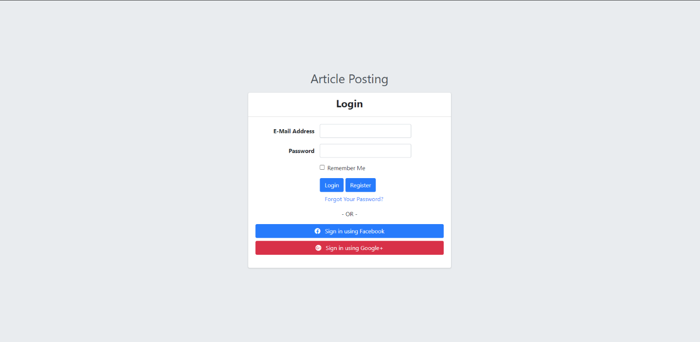Login
  + Register
  + Logout
  + Users
    - List users
    - Delete users
    - Update users
    - View user detail

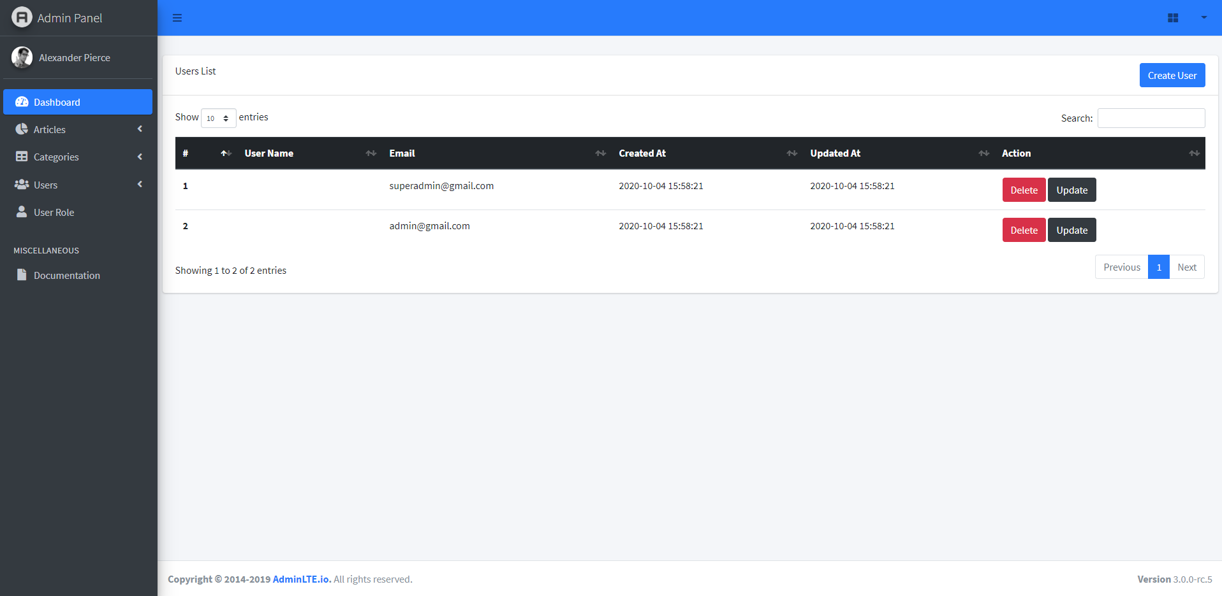

* Category
  + List category
  + Delete category
  + Update category
  + View category
  + 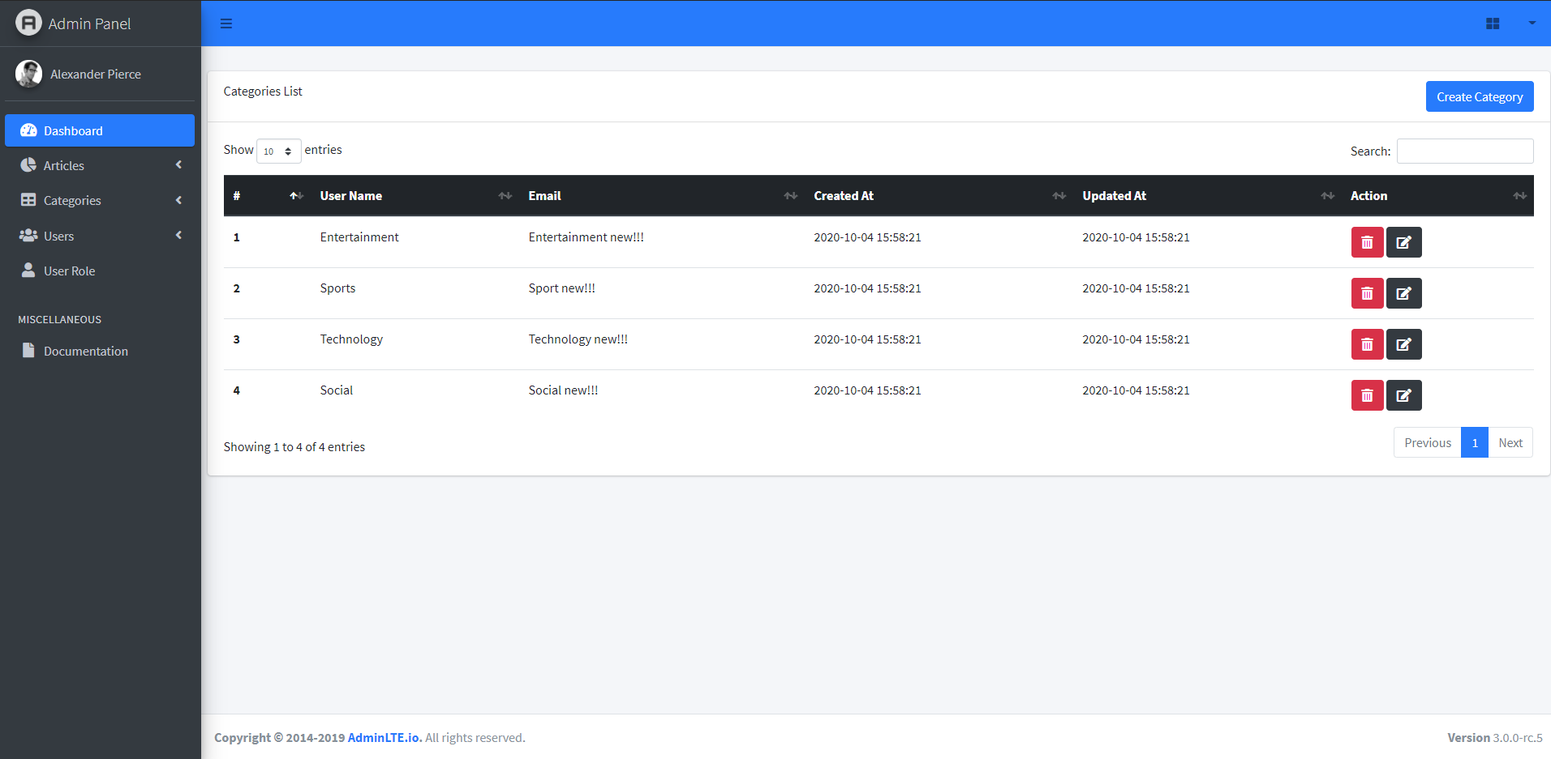
* Article
  + 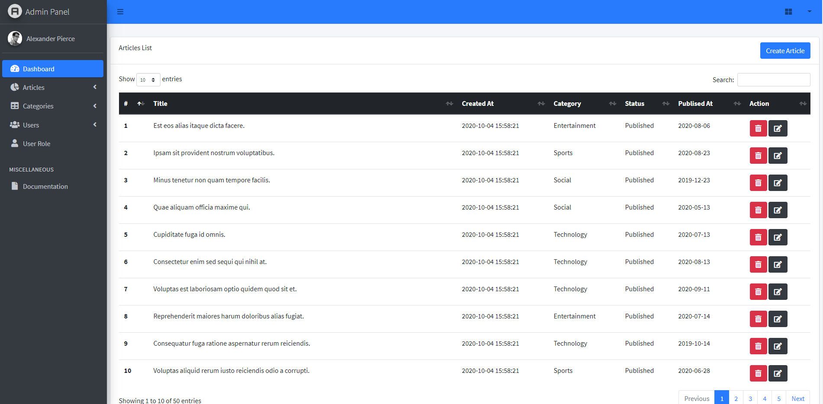List Article
  + Delete Article
  + 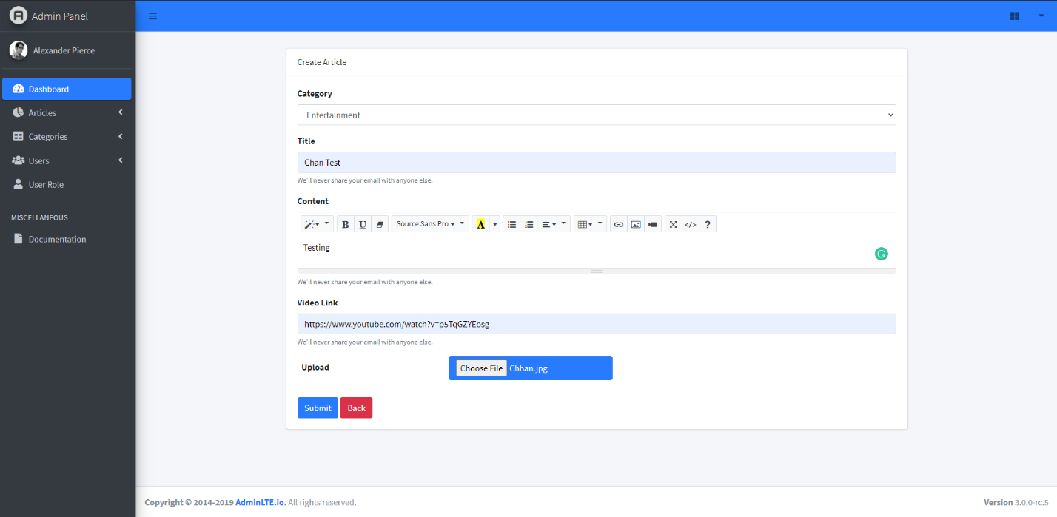Post Article
  + Update Article

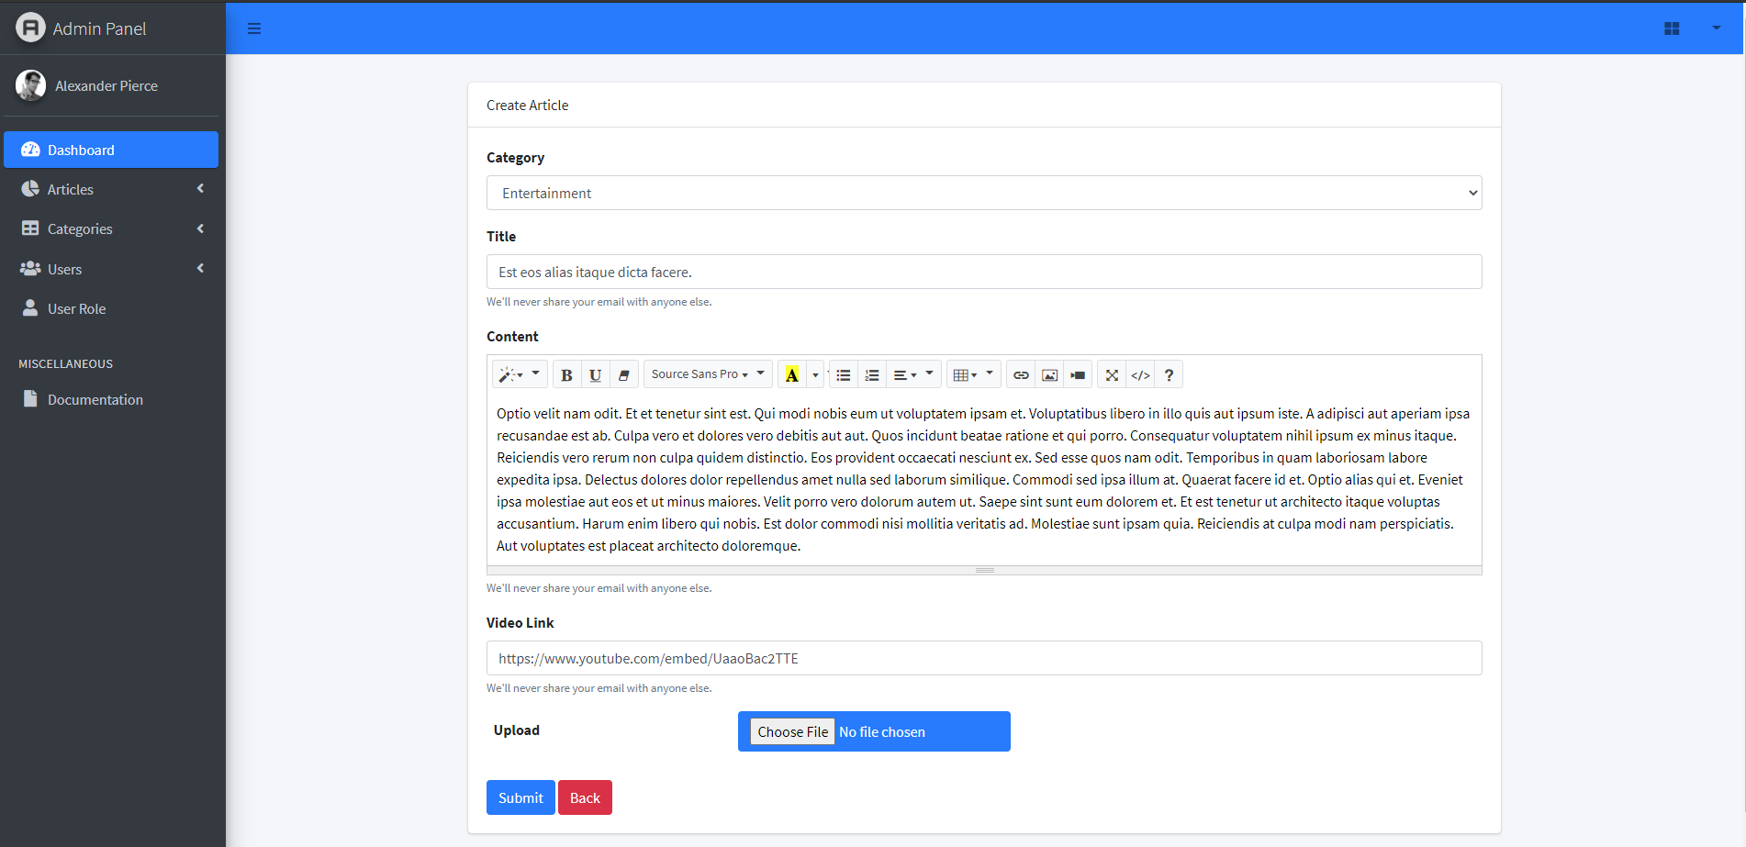

* + View Article
  + Publish Article
* User
* 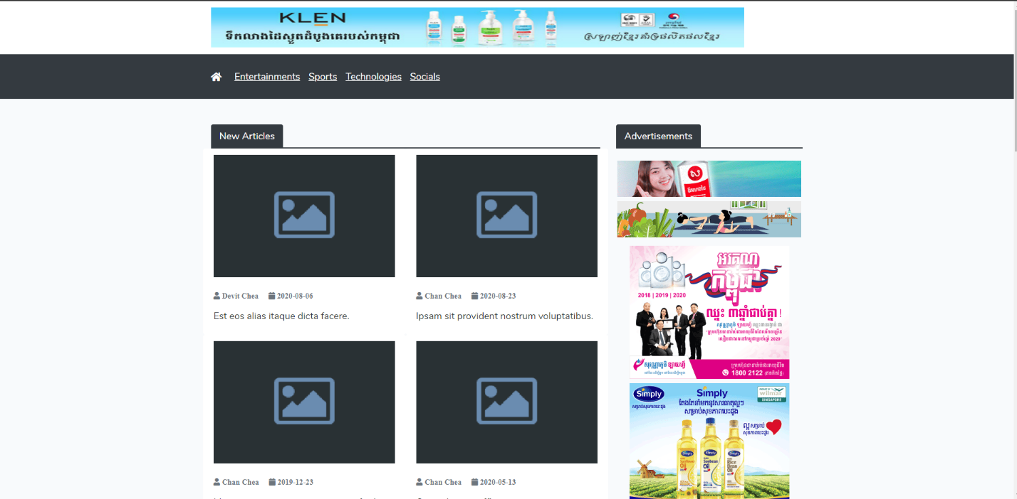Home Page
* Entertainment Page

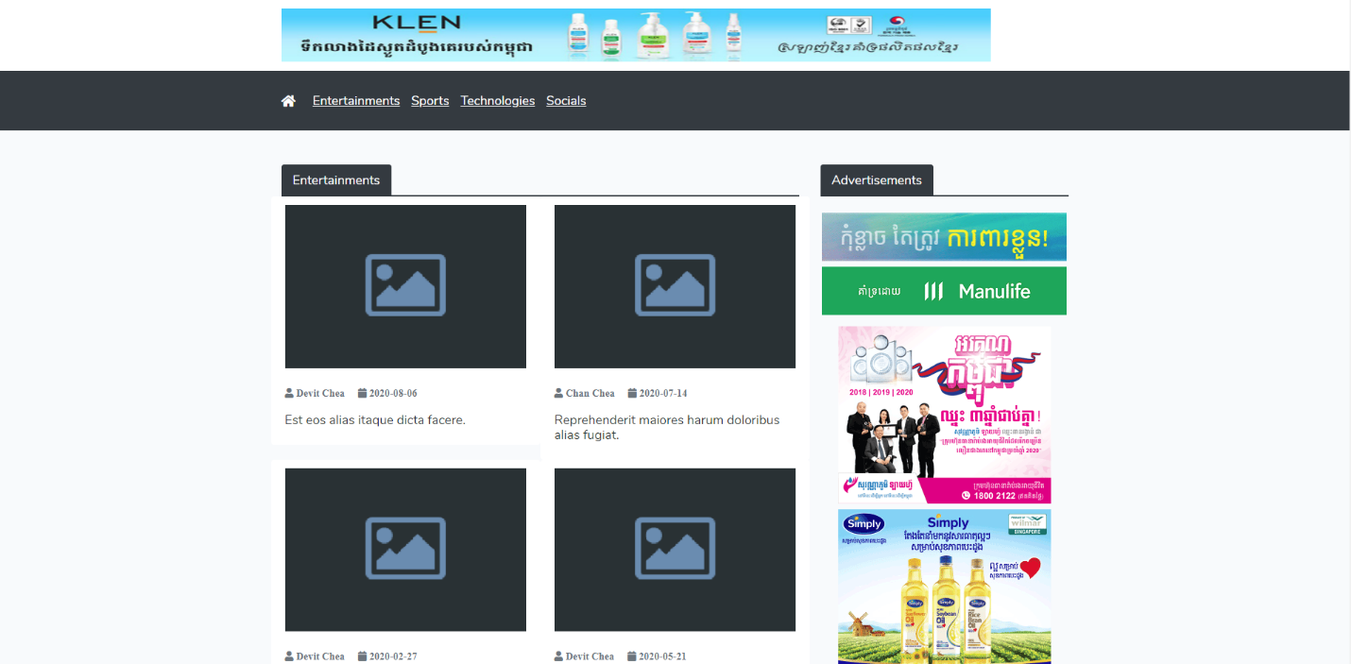

* Sport Page
* Social Page
* Technologies Page
* Share so social media
* Amount viewer

1. **Task Responsibility Of Each Other**

* **Team**:
* Analyst and Database Design: We discuss with each other how to design and explain about the process of our system to make sure everyone in team understand the purpose of system. Know what to do.
* We involved with coding together, sharing the task and help each other for fixing error
* **Chea Devit:**
* Database migration => Create database seeder => User admin, category and create faker data for article list & CRUD article
* After member push code, Devith will merge code and fixing the conflict file
* Add advertise to each list
* **Chea Chan**:
  + Init project and push project to github
* Login & Register & CRUD users
* Right contain
* Divide task for each members
* Follow up
* Testing and feedback
* **Neam Sinat**:
* Footer of website
* Design articles & entertainment home page and fetch data from database to view
* Do slide presentation

* **Thorng Danet** :
* Design Social and Technology page and fetch data from database to view on page
* Design article detail
* Advertisements on article detail page
* Prepare Document Project Report
* Add document teacher’s project requirement needed
* **Roeurn Chantha**:
* Design Sport page and fetch data from database to the view
* Article list
* Advertisements on article list page
* Task responsibility
* **Chhunhak Chhoeurng**:
* Design Article detail
* Add pagination in each list
* Design front end
* Push project to the github
* Team meeting before finish
* Close project version 1.0.40

**III. The best 5 special features in the system**

1. CRUD Users
2. CRUD Article
3. CRUD Category
4. List the article with different categories
5. Article details

**Conclusion**

Article post is a piece of writing on a website with a front page with multiple links -- or content not displayed in reverse chronological order -- I would call an article. A “post” is a piece of writing on a blog, for example, Addressed to you which is delivered by a postal operator. There are different types of postal articles available. These include ordinary mail, registered mail, bulk mail, express mail etc.

As a conclusion, the proposed website will bring benefits to all users. Much of general knowledge can be helped for good communication technology. It aims to assist users in achieving their respective goals and objectives.

Reference: https://adminlte.io/docs/3.0/